Ellipsis
I only said, 'If we could . . .'.

In British English every sequence of words before or after four points should be functionally complete.

? and !
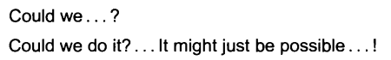

Interruption, pause, irony, rhetorical
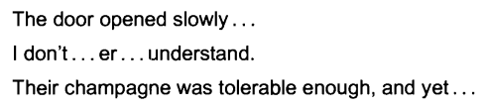

= etc.

Question mark

Did she really say that?
You’e coming, aren't you?

Would you kindly let us know whether to expect you?
I wonder if I might ask you to open the window?
vs
May I take this opportunity to wish you all a safe journey.
Will everyone please stand to toast the bride and groom.

Do you want more lardycake? Buns? Muffins?
You will be back before lunch, right? About noon? Good.
vs
Where now? they wonder.
He pondered why me? till his head hurt.

Direct speech:
‘Why not?’ she wondered.
She wondered, ‘Why not?’

Other uses
Doubt

Space needed:

Dates in doubt
Geoffrey Chaucer (?1340-1400)

Exclamation mark

Obvious use

(!) vs [!]

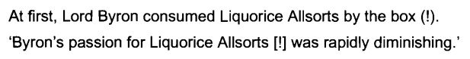

Hyphens and dashes

‘hard’ hyphen vs ‘soft’ hyphen

NOTE
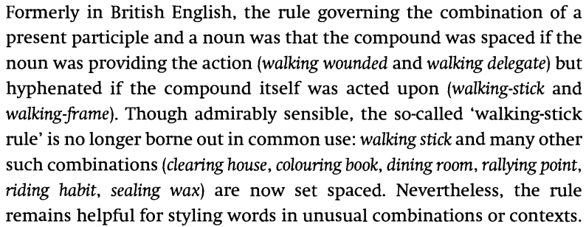

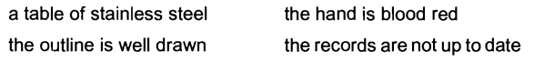
vs

Compare and tell the difference
a stainless steel table vs a stainless-steel table
a little used car vs a little-used car

Italics and foreign phrases
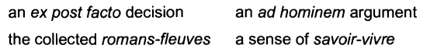

Capitalized words

Prefixes and combining forms

Vowel/consonant collision
re-entry
non-negotiable

Confusion
re-form vs reform
recover vs re-cover

Prefixes
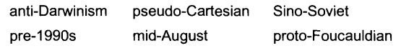

Names
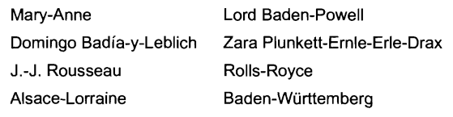

Numbers
twenty-three, four hundred and sixty-eight, fifty-three thousand, two-thirds, four and five-eights

Compass points
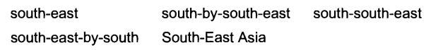
But:
southeaster northwester (of winds)

Other uses

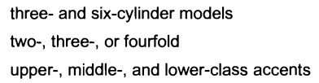

Word division

there, watch, though, prayer, wrought

helped, passed, grasped

ph as in atmos-phere, gn as in poign-ant, ea as in crea-ture

-cious, -dal, -don, -gion, -gious, -sion, -tial, -tion

Avoid
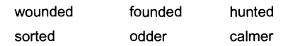

Schwa
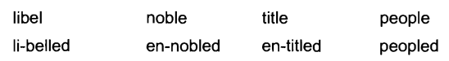

3 letters before and after the division
Exception – 2 letters before

Use existing hyphens
Counter-clockwise

Use etymology
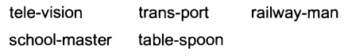

Avoid mispronunciation
Chil-dren vs child-ren, dem-ocracy vs demo-cracy
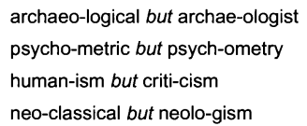

carry-ing
admit-ting
chuck-ling
puz-zling

Etymology useless

Avoid oddity

hyphen (-), en dash/rule (–), and em dash/rule (—).

http://www.chicagomanualofstyle.org/qanda/data/faq/topics/HyphensEnDashesEmDashes/faq0002.html

En rule

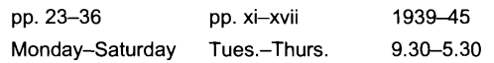

the 1939-45 war vs the war from 1939 to 1945

OR NO SPACE between the en rule and parenthesis

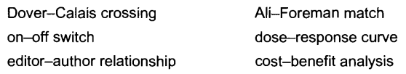

the Lloyd-Jones theory vs the Lloyd-Jones–Scargill talks

Arab–American vs Arab-American

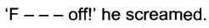
Or use *

Dash (em rule)
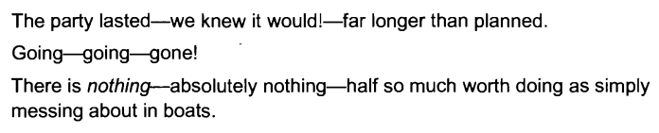
Also possible to use en rule and space on either side

Introduce a phrase at the end of a sentence or replace an introductory colon
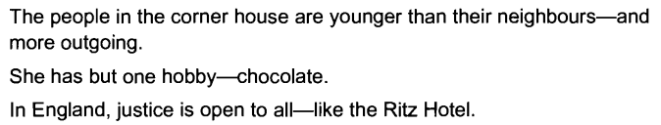

Em rule
spaced to indicate the omission of a word, and closed up to indicate the omission of part of a word

Closed up for interruption in dialogue
